
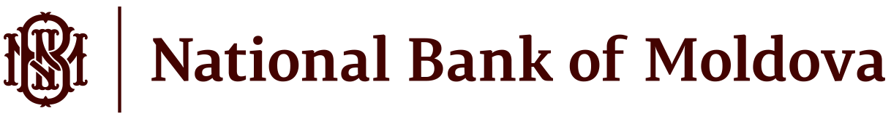

ANNUAL BUDGETED EXPENDITURE AND CAPITAL EXPENDITURE BUDGET
of the National Bank of Moldova approved for 2025 by the Decision of the Supervisory Board no. 39 of December 16, 2024

Annual budgeted expenditure of the National Bank of Moldova
The annual budgeted expenditure of the National Bank of Moldova for 2025 was approved in amount of MDL 657,333 thousand, as follows:

(thousand, MDL)
Item | Approved
Expenses related to services provided to NBM | 8,438
Personnel expenses | 406,110
Social security contribution and other insurance expenses | 116,203
General expenses | 48,339
Repairs and maintenance expenses | 27,314
Write offs of non-financial assets | 80
Social expenses | 3,169
Impairment of non-financial assets and other provisions | 11
Depreciation and amortisation expenses | 47,669
Total expenses | 657,333

Capital expenditure budget of the National Bank of Moldova

Capital expenditure budget of the National Bank of Moldova for 2025 was approved in amount of MDL 177,907 thousand (including allowances for multiannual projects in amount of MDL 87,595 thousand), with MDL 62,728 thousand allocated for payments in 2025, as follows:
(thousand, MDL)
Item | Capital expenditure allowances approved  2025-2030 | Capital expenditure in 2025  (payments)
Hardware | 14,426 | 14,426
Computer software and licenses | 20,485 | 20,485
Machinery and equipment | 8,847 | 8,847
Household equipment | 8,938 | 8,938
Building construction, capital repairs | 2,511 | 2,511
Other capital expenditure, of which for: | 122,700 | 7,521
- capital projects | 87,595 | 0
Total capital expenditure budget | 177,907 | 62,728

