
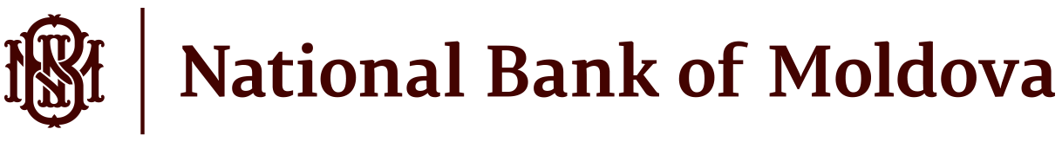

ANNUAL BUDGETED EXPENDITURE AND CAPITAL EXPENDITURE BUDGET
of the National Bank of Moldova approved for 2026 by the Decision of the Supervisory Board no. 43 of December 11, 2025

Annual budgeted expenditure of the National Bank of Moldova
The annual budgeted expenditure of the National Bank of Moldova for 2026 was approved in amount of MDL 761,365 thousand, as follows:

(thousand, MDL)
Item | Approved
Expenses related to services provided to NBM | 13,216
Personnel expenses | 474,401
Social security contribution and other insurance expenses | 135,815
General expenses | 53,526
Repairs and maintenance expenses | 31,985
Write offs of non-financial assets | 80
Social expenses | 2,070
Impairment of non-financial assets and other provisions | 20
Depreciation and amortisation expenses | 50,252
Total expenses | 761,365

Capital expenditure budget of the National Bank of Moldova

Capital expenditure budget of the National Bank of Moldova for 2026 was approved in amount of MDL 173,735 thousand (including allowances for multiannual projects in amount of MDL 107,038 thousand), with MDL 71,278 thousand allocated for payments in 2026, as follows:
(thousand, MDL)
Item | Capital expenditure allowances approved  2026-2028 | Capital expenditure in 2026  (payments)
Hardware | 16,520 | 16,520
Computer software and licenses | 26,072 | 26,072
Machinery and equipment | 3,269 | 3,269
Household equipment | 4,995 | 4,995
Building construction, capital repairs | 6,440 | 6,440
Other capital expenditure, of which for: | 116,439 | 13,982
- capital projects | 107,038 | 9,108
Total capital expenditure budget | 173,735 | 71,278

